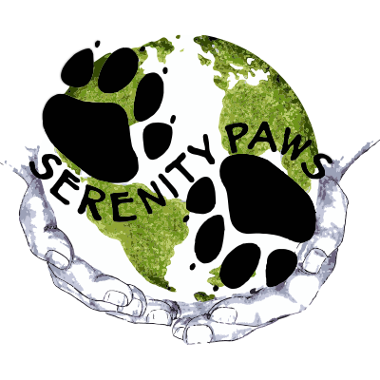
WELCOME TO SERENITY PAWS
Thank you for giving us the opportunity to care for your pet!
Owner (s) _______________________________________________________________
Address ______________________________________________ Apt ___________
City, State _____________________________________________ Zip_____________
Email address____________________________________________________________
Phone numbers Please circle one
Primary (_____)___________________ Home/Cell/ Work
Second (_____)___________________ Home/Cell/Work
Third (_____)___________________ Home/Cell/Work
How did you hear about our business?
________________________________________________________________________
PET INFORMATION
Pet 1 Name ________________________________________Dog _______ Cat ______
Breed ________________________________ Color__________ Birthdate__________
Male _____ Neutered _____ Female _____ Spayed _____ Microchip# __________
Pet 2 Name ________________________________________Dog _______ Cat ______
Breed ________________________________ Color__________ Birthdate__________
Male _____ Neutered _____ Female _____ Spayed _____ Microchip# __________
Pet 3 Name ________________________________________Dog _______ Cat ______
Breed ________________________________ Color__________ Birthdate__________
Male _____ Neutered _____ Female _____ Spayed _____ Microchip# __________
Veterinarian/Clinic _________________________________________________________
Vaccination history provided Y / N Please call my veterinarian for vaccine dates _____
Special health/behavior concerns: ______________________________________________

Owner signature ______________________________________ Date ______________

GROOMING RELEASE
As your professional Pet Stylist/Hygienist, our primary concern is the health, comfort, safety and overall well-being of your pet. We are committed to going above and beyond all safety and sanitation requirements set by PACFA to maintain a safe and clean environment for your pet.
It is required that you provide the facility with a copy of your pet's current immunization record from your veterinarian. Serenity Paws requires your pet to be current on the Bordetella (kennel cough), Rabies and Distemper combination vaccinations. These vaccines protect your pet and the other pets in our facility from common communicable diseases. It is still possible for your pet to contract these diseases, especially kennel cough, despite being vaccinated. Serenity Paws will not be liable for any such conditions; as well as any allergic reactions caused by any grooming product used, nor any injury, illness, death or loss while in our facility.
In case of emergency, the owner designates Serenity Paws as agents and understands that Serenity Paws will do whatever is necessary and appropriate for the well-being of your pet while in our care. If your pet becomes ill or injured, we will attempt to contact you. If we are unable to contact you, we may engage the services of a veterinarian at our discretion and at the owner's expense.
While in our care, tethers (non-tightening grooming noose/collar) will be used to secure your pet while grooming. At the groomer's discretion, a muzzle may be used for the safety of the pet and our staff. These items will only be used on your pet under direct supervision. If your pet is here for a long period of time, we will walk your pet outside securely on a slip lead. Please advise us if this is not ok.
Your pet may be given an accessory such as bows, flowers or bandanas. As a safety precaution, it is the owner’s responsibly to remove items when the grooming service is complete in order to avoid ingestion or choking hazards.
RELEASE OF LIABILITY ESPECIALLY FOR GERIATRIC and SPECIAL NEEDS PETS
We prioritize your pets’ comfort and well-being above all else. However, if you have a pet in the older stages of life, they are at greater risk for incidents in the salon. Older pets may suffer greater strain from the grooming process and be fatigued or anxious as a result of the process (also common with pets that are not accustomed to the grooming as a part of their regular lifestyle). Serenity Paws will accommodate client’s special needs as much as possible. Though incidents are extremely rare, Serenity Paws must be released of any liability arising as a result of your pet’s visit to the salon in order to work with your pet.

1) Pets that may be matted: Many mats can be brushed out but in more severe cases, the mats can be extremely tight to the skin and are dangerous and painful to brush out. We would like permission to shave tight mats
YES NO N/A

2) Does your pet have any behavioral/medical problems or special needs that we should know about? For example: aggression, heart disease, seizures, allergies, etc.
Please describe:
_____________________________________________________________________________________

3) Has your dog ever bit anyone?
YES NO

4) May we photograph your pet for promotional/educational purposes?
YES NO

5) Is your pet disabled, elderly/geriatric? If yes, please also fill out a geriatric release form.
YES NO N/A
I acknowledge that I have been shown the release form and I agree to terms and conditions within the release form.
Owner/Agent signature Date

__________________________________ ____________________________

